stage 7 is perfection not pre-awakening that is an error from the notebook llm tool to be noted.
also below is the summary of the insight sent before: Summary of Key Insights
This conversation established a clear architectural logic for mapping human evolution across a 7-layer spectrum. Instead of a linear progression, the framework is an Inversion Model with a central pivot:
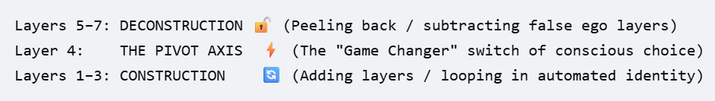
The Middle-Band Problem Solved: The friction in the draft spreadsheet stemmed from treating the middle layers as a standard progression. By redefining them through the Construction → Switch → Deconstruction lens, the internal logic of the Brainstorm and Patanjali systems aligns with reality without contradicting Vedic/Yoga traditions.
- The Layer 3 Correction: It is not a transition zone. It is the absolute peak of the automatic loop where the individual is firmly trapped by external optimization and material power (p. 5).
- The Layer 5 Reframing: Spiritual progression here is not an aggressive struggle or "holding reins firmly." It is about internal steadying and using spiritual practice to un-wear and clear the stored impressions of memory (p. 9).
Concrete Next Steps
To advance this project and integrate it into your website, 42self.xyz, proceed with these technical and content steps:
1. Update the Master Matrix Sheet
Manually replace the vocabulary in your draft spreadsheet for the problematic rows using the realigned terminology:
- Row 3 (Brainstorm): Change from "State → Consciousness transitioning" to Consolidated State (The Closed Identity Loop).
- Row 3 (Patanjali): Frame as Ahamkara Dominant (The Closed Mental Loop).
- Row 5 (Brainstorm): Change from "Consciousness sustained" to Integrated Consciousness (Deconditioning Begins).
- Row 5 (Patanjali): Change from "Charioteer trained — reins held firmly" to Charioteer Steady (Stabilization / Clearing Samskaras).

